Future Reference Document: (Tree for Scraping)

If any kind of changes is made to the website please look at this documentation.

* Navigate and get the data: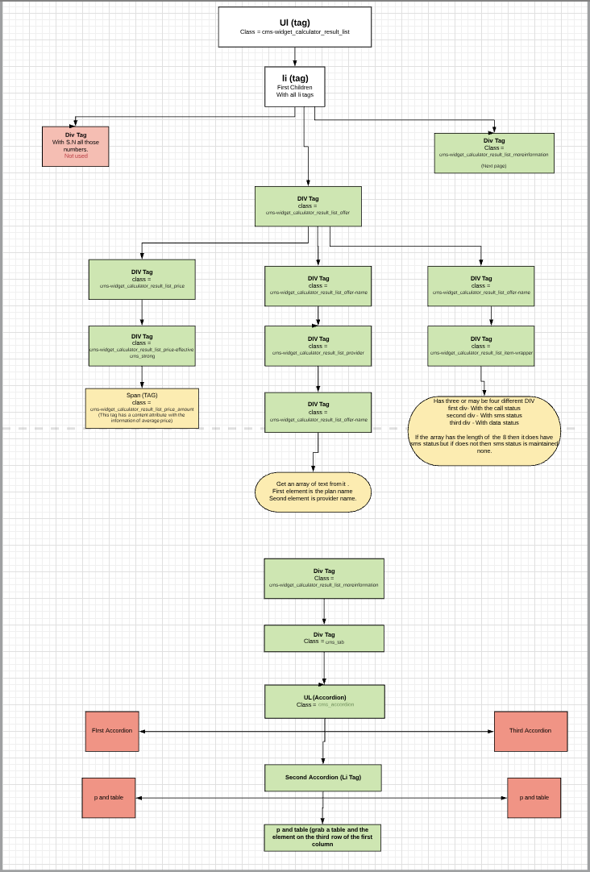

(Picture is also available)

* Navigate through Pages using URL:

Right now there are 8 pages and navigated changing the url last query parameter page to a specific page number

[https://www.preis24.de/handy-flatrate-vergleich/?mobiletariffCalculatorForm=true%20#%20&mergeDefaults=false&productType=mobile&sortBy=monthlyEffectiveCost&sortDirection=%20#%20up&partnerId=1665&telephony=&telephonyMinutePackageMin=50&numberPorting=any&sms=%20#%20&smsPackageMin=50&internetVolumeMin=&maxDownloadSpeedKb=&maxCostsMonth=&deviceType=%20#%20none&maxCostsHardwareOnce=150&network%5B%5D=1&network%5B%5D=2&network%5B%5D=4&carrier=%20#%20&maxTariffsPerProvider=&type=vertrag&maxContractRuntime=&customerGroup=&simCardType=%20#%20&signupAvailableOnly=true&page=1](https://www.preis24.de/handy-flatrate-vergleich/?mobiletariffCalculatorForm=true%20#%20&mergeDefaults=false&productType=mobile&sortBy=monthlyEffectiveCost&sortDirection=%20#%20up&partnerId=1665&telephony=&telephonyMinutePackageMin=50&numberPorting=any&sms=%20#%20&smsPackageMin=50&internetVolumeMin=&maxDownloadSpeedKb=&maxCostsMonth=&devi)